Ras (G12S)
Catalog Number: CR-M26186
Gene Symbol: H-Ras; K-Ras; N-Ras
Description: Anti-RAS (G12S) Mouse Monoclonal Antibody

Background: Ras protein is a membrane-associated GTPase signaling protein that regulates proliferation, differentiation, and cell survival. Ras G12S mutation result in decreased GTPase activity and constitutive signaling, and is correlated with the development of pancreatic intraepithelial neoplasia and lung lesions.
Immunogen: A synthetic peptide from the internal region of RAS which includes the mutation of G12S, human origin.
Tested applications: ELISA, WB, IHC
Recommended dilutions:
ELISA: 1:1000-1:5000
WB: 1:500-1:1000
IHC: 1:50-1:100
Concentration: 1 mg/ml
Host: Mouse
Clonality: Monoclonal
Purity: Purified from ascites
Format: Liquid
Storage buffer:
Preservative: no
Constituents: PBS (without Mg²⁺ and Ca²⁺), pH 7.4, 150 mM NaCl, 50% glycerol
Species Reactivity: Recognizes G12S mutant, but not wild-type RAS of vertebrates.
Storage Conditions: Store at -20°C. Avoid freeze / thaw cycles.

Western blot:
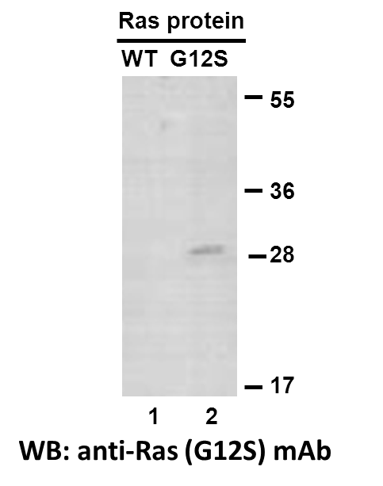
Western blot analysis of recombinant RAS (G12S) and wildtype proteins. Purified His-tagged RAS (G12S) protein (lane 2) and corresponding wildtype protein (lane 1) were blotted with anti-RAS (G12S) monoclonal antibody (Cat. #26186).

Immunofluorescence:
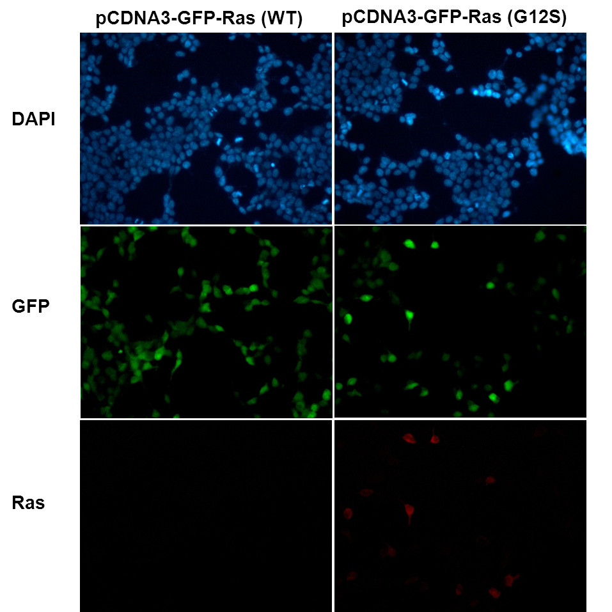
Immunofluorescence of cells expressing RAS proteins with anti-RAS (G12S) antibody. HEK293T cells were transfected with pCDNA3-GFP-RAS (WT) plasmid (left column) or pCDNA3-GFP-RAS (G12S) plasmid (right column), then fixed and stained with anti-RAS (G12S) monoclonal antibody (Cat. #26186).

科博瑞（武汉）生物科技有限公司
TEL：027-87615885 15972062685
- mail：3636901710@qq.com
Web:www.coburybio.com

